ER Modelling Exercise – Hospital

Consider the following requirements for inpatients at a hospital:

All patients admitted to the hospital are given a unique patient number. The patient’s name, address, age, and sex are recorded. Private patients are allocated a private room, identified by the room number. Private rooms are of different types, e.g., standard, deluxe, palatial, etc. NHS patients are allocated a bed in a ward, beds being identified by the ward name and bed number. Wards are of different types, e.g., pediatric, cancer, etc, with a named sister in charge of each one. Each patient is allocated to a named consultant who supervises the medical care of the patient. The consultant decides on the treatments to be given to the patient. A treatment is any medical procedure performed on the patient. Each treatment is given a unique treatment number, and a description of the treatment and the date it is performed are recorded.

Design an E-R diagram for the above database. Derive a corresponding relational scheme from your E-R diagram.

The E-R diagram must show attributes, keys, cardinalities, and constraints. The relational scheme must be in third-normal form, with primary and foreign keys clearly indicated.

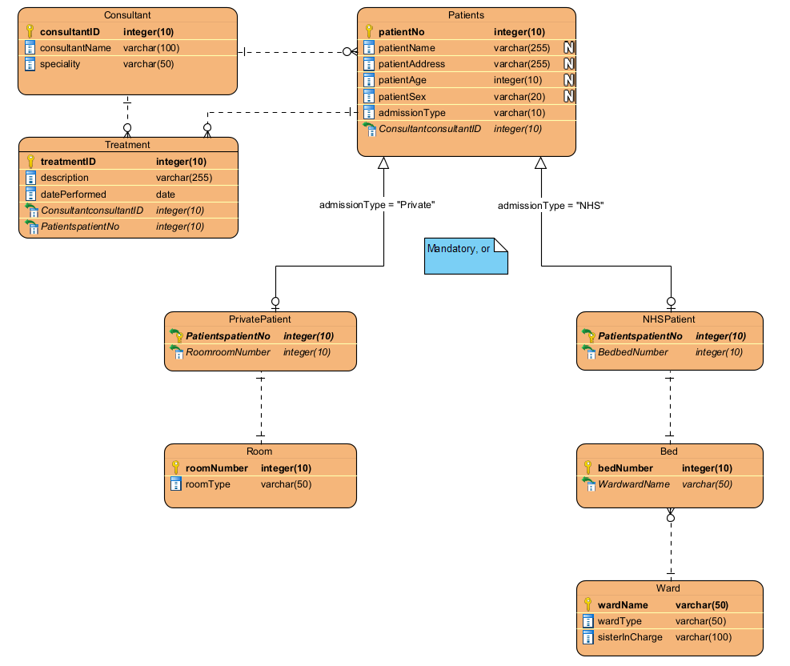

Relational Model:

Patients (**patientNo**, patientName, patientAddress, patientAge, patientSex, admissionType, consultantID)

FOREIGN KEY consultantID REFERENCES Consultant (consultantID)

PrivatePatient (**patientNo**, roomNumber)

FOREIGN KEY patientNo REFERENCES Patients (patientNo)

FOREIGN KEY roomNumber REFERENCES Room (roomNumber)

NHSPatient (**patientNo**, bedNumber, wardName)

FOREIGN KEY patientNo REFERENCES Patients (patientNo)

FOREIGN KEY bedNumber REFERENCES Beds (bedNumber)

FOREIGN KEY wardName REFERENCES Ward (wardName)

Consultant (**consultantID**, consultantName, speciality)

Treatment (**treatmentID**, description, datePerformed, patientNo, consultantID)

FOREIGN KEY patientNo REFERENCES Patients (patientNo)

FOREIGN KEY consultantID REFERENCES Consultant (consultantID)

Room (**roomNumber**, roomType, patientNo)

FOREIGN KEY patientINo REFERENCES Patients (patientNo)

Ward (**wardName**, wardType, sisterInCharge)

Bed (**bedNumber**, wardName)

FOREIGN KEY wardName REFERENCES Ward (wardName)